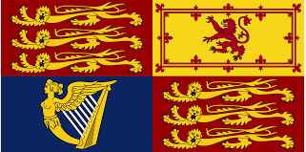

28th April 2022

Dear parents and carers,

On Wednesday 25th May from 3:30-4:30pm Jessop Primary school will be marking Queen Elizabeth the 1st’s Platinum Jubilee by hosting the Jessop Jubilee Tea party. All pupils, parents and staff are invited to come along and share in the snacks and activities that will be available on the day.

A flyer for the event, along with further information will follow soon. Parent forums originally scheduled for the 25th will be rescheduled and the new dates will be shared in due course.

Yours Sincerely,

K. Baffoe

